Special Families East Grinstead Library

Adult’s Books

We hold the following books in our library. We have tried to categorise them to help you find what may be useful to you more easily. We have used the following categories.
- ADHD
- Anxiety
- Attachment
- Autism Spectrum Disorder and Asperger’s Syndrome
- Behaviour
- Carer’s Support
- Cerebral Palsy
- Communication
- Dyslexia
- Home Education
- Internet Safety
- Learning Difficulties
- Legal Aspects
- Pathological Demand Avoidance
- Premature Babies
- Sensory Processing Disorder
- Signing
- Special Needs – Identifying
- Tube Feeding

Against each book we have added a brief synopsis. Please note that these have been copied and pasted from sites where these books are sold. The inclusion of the synopsis is meant to give a brief overview and does not represent the opinions of Special Families East Grinstead.

ADHD

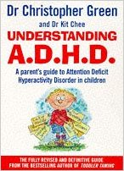 | Understanding ADHD, Dr Christopher Green & Dr Kit Chee  In his typically friendly and clear style, the ever-popular Dr Chris Green, with Dr Kit Chee, explains the treatments and causes of Attention Deficit Disorder, a condition that affects the learning and behaviour of up to 1 in 10 children in this country.  Aimed at parents, teachers and health professionals, this book dispels the myths about ADHD and gives a clear overview of the condition: the causes, the behaviours and the treatments.  Full of well-tried, practical strategies to help with common problems such as inattention, underachievement and impulsiveness, the book covers:  - The causes, how to help improve behaviour at home and at school  - Making the diagnosis, medication and alternative therapies  - Hints to help reading, writing and language  - Ways to boost self-esteem  - ADHD in adults  - The latest research and where to go for further help  Understanding ADHD offers invaluable guidance to help parents work with teachers and health professionals to give their child the best possible chance of entering adulthood with self-confidence, life skills and secure family relationships.

Anxiety

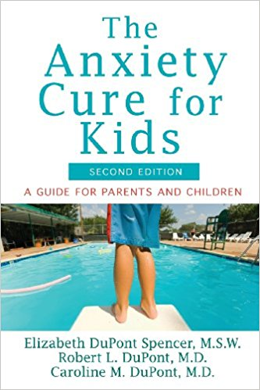 | The Anxiety Cure for Kids: A Guide for Parents and Children, Elizabeth Dupont Spencer, Robert L Dupont, Caroline M Dupont  The up-to-date, practical guide for helping your child deal with anxiety. Fear, worry, stomach pains, self–doubt, these are classic symptoms of anxiety in children. Using kid-friendly concepts, this reassuring guide helps adults and children understand the powerful ways in which anxiety works and how to overcome its negative effects. This revised edition includes all new chapters on food phobia; the relationship between anxiety and other illnesses and problems such as ADHD, depression, and autism; and anxiety in teens.  The lessons in The Anxiety Cure for Kids have helped many children break free from anxiety. By making changes little by little, any child with anxiety can get well and stay well. Provides up-to-date, practical guidance for helping both younger children and teenagers deal with anxiety issues. Shows how to recognize the symptoms of anxiety, evaluate a child′s need for medication and/or therapy, assess the role of the family in anxiety disorders, and take concrete steps to find solutions. Explains how to communicate effectively with your child, help him or her confront fear, and boost your child′s feelings of accomplishment and self-esteem. Addresses a range of anxiety disorders, such as food phobia and anxieties about terrorism, as well as the relationship between anxiety and other illnesses. Also includes advice that can be used by teachers, coaches, doctors, therapists, school nurses, and others who work with anxious kids.
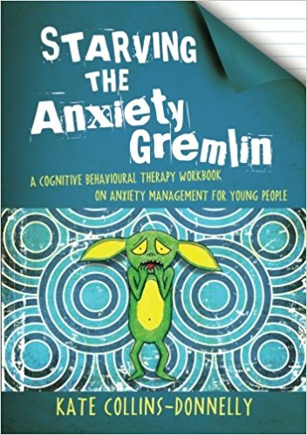 | Starving the Anxiety Gremlin, Kate Collins-Donnolly  The Anxiety Gremlin loves one thing - to feed on your anxiety! But watch out, as the fuller he gets, the more anxious you get! How can you stop him? Starve him of his favourite food - your anxiety - and he'll shrink and shrivel away. Starving the Anxiety Gremlin is a unique resource to help young people understand different types of anxiety and how to manage them, including panic attacks, phobias, social anxiety, generalised anxiety and obsessive compulsive disorder. Based on cognitive behavioural principles that link thoughts, feelings and behaviours, the techniques described help young people to understand why they get anxious and how they can 'starve' their anxiety gremlin in order to manage their anxiety. This engaging workbook uses fun activities and real life stories, and can be used by young people aged 10+ on their own or with a parent or practitioner. It is also an ideal anxiety management resource for those working with young people, including mental health practitioners, social workers, education sector staff and youth workers.
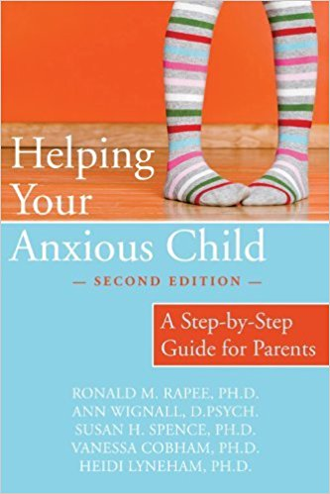 | Helping Your Anxious Child, Ronald M Rappee & Others  This expanded and updated version of a best-selling classic guides readers to help a child overcome anxiety and fears. It describes in detail strategies and techniques they can combine into a comprehensive self-help programme for a child's particular needs. From separation anxiety to general anxiety, social anxiety, specific phobia and panic disorder, the book describes the common types of childhood anxiety, how anxiety originates, and options for dealing with the problem, with or without a therapist's help.  In this updated version, the progression of chapters reflects the authors' clinical programme, in which major skills are introduced early and then are consolidated and built upon in later chapters. Throughout, the book employs a step-by-step approach that is both structured and directive. Written activities are incorporated throughout the chapters, some intended for the child and others for his or her parent to complete.
Other booklets and information guides | Anxiety: A Guide for Parents – published by Cerebra

Attachment

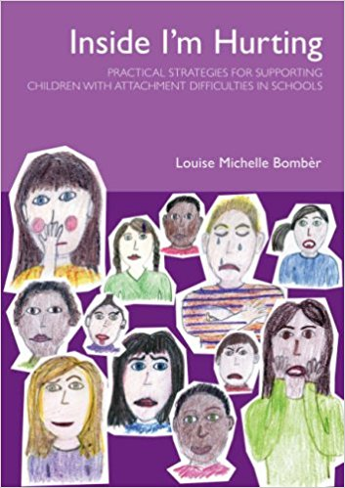 | Inside I'm Hurting, Louise Michelle Bomber  Inside I'm Hurting provides educational professionals with a much-needed classroom handbook of new strategies, practical tools and the confidence for supporting these children from an attachment perspective, thus promoting inclusion in the school system. Contents include: how attachment difficulties can affect a child's ability to learn; providing an 'additional attachment figure' in schools; the benefits and challenges of getting alongside children who have experienced trauma and loss; transitions during the school day; permanency and constancy; being explicit; regulating arousal levels; handling conflict; wondering aloud; lowering the effects of shame; working with transition from primary to secondary phase; developing effective home/school partnership (includes a photocopiable initial meeting prompt card); providing staff support; recommendations for future action.
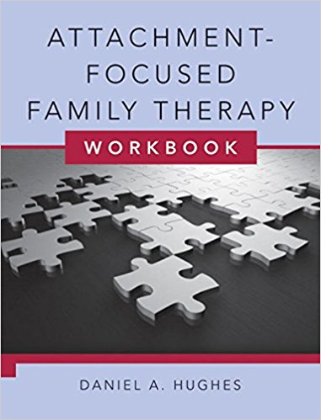 | Attachment-focused Family Therapy, Daniel A Hughes  A practical workbook companion to the best-selling text that brought attachment into the realm of family therapy. Daniel A Hughes, a leading practitioner in his field, specialises in an attachment-oriented approach to family therapy. Applying his model to children and families with a range of psychological problems, this book distils just the clinical strategies, offering practitioners a host of practical exercises and interventions on the core skills of his treatment programme.

Autism Spectrum Disorder and Asperger’s Syndrome

The Complete Guide to Asperger's Syndrome, Tony Attwood
This book brings together a wealth of information on all aspects of the syndrome for children through to adults. Drawing on case studies and personal accounts from Attwood's extensive clinical experience, and from his correspondence with individuals with AS, this book is both authoritative and extremely accessible. The chapters examine: causes and indications of the syndrome; the diagnosis and its effect on the individual; theory of mind; the perception of emotions in self and others; social interaction, including friendships; long-term relationships; teasing, bullying and mental health issues; the effect of AS on language and cognitive abilities, sensory sensitivity, movement and co-ordination skills; and, career development.
There is also an invaluable frequently asked questions chapter and a section listing useful resources for anyone wishing to find further information on a particular aspect of AS, as well as literature and educational tools.
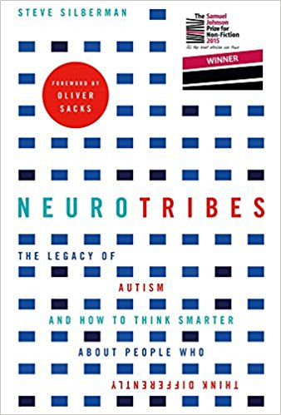 | NeuroTribes: The Legacy of Autism and How to Think Smarter About People Who Think Differently, Steve Silberman  What is autism: a devastating developmental condition, a lifelong disability, or a naturally occurring form of cognitive difference akin to certain forms of genius? In truth, it is all of these things and more – and the future of our society depends on our understanding it. Following on from his ground-breaking article 'The Geek Syndrome', Wired reporter Steve Silberman unearths the secret history of autism, long suppressed by the same clinicians who became famous for discovering it, and finds surprising answers to the crucial question of why the number of diagnoses has soared in recent years. Going back to the earliest autism research and chronicling the brave and lonely journey of autistic people and their families through the decades, Silberman provides long-sought solutions to the autism puzzle while casting light on the growing movement of 'neurodiversity' and mapping out a path towards a more humane world for people with learning differences.  **WE HOLD 2 COPIES OF THIS BOOK**
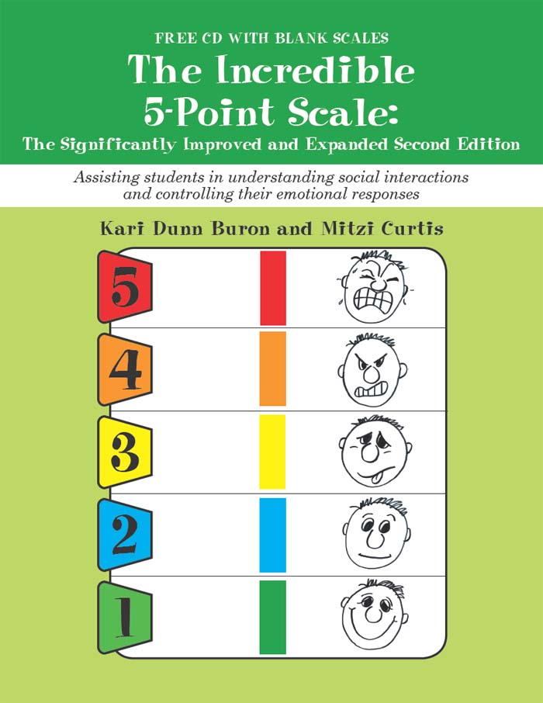 | The Incredible 5-point Scale, Kari Dunn Buron & Mitzi Curtis  This much-awaited second edition of the popular Incredible 5-Point Scale is, as the title suggests, significantly improved and expanded. Using the same practical and user-friendly format as the first edition, Buron and Curtis let readers benefit from work done with the scales over the past 10 years, to result in refinements to the original scales, now considered classics in homes and classrooms across the country and abroad, as well as lots of new scales specifically designed for two groups of individuals: young children and those with more classic presentations of autism, including expanded use of the Anxiety Curve. Another welcome addition is a list of goals and objectives related to incorporating scales in students IEPs. Note: Blank scales are free downloadable.CD not included. As in their other writings, the authors emphasise the importance self-management and self-regulation, two evidence-based practices.
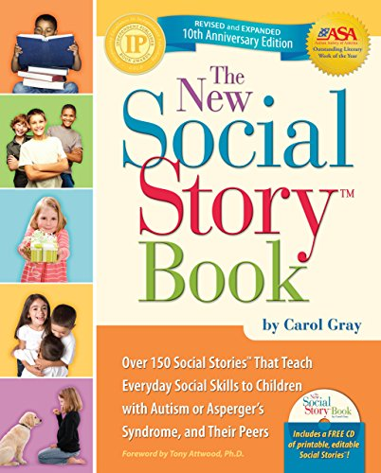 | The New Social Story Book Including CD, Carol Gray  Since the early 90s, Carol Gray's world-famous Social Stories have helped thousands of children with autism spectrum disorders. This 10th Anniversary edition of her best-selling book offers the ready-to-use stories that parents and educators have depended on for years, but now features over 25 additional Social Stories, groundbreaking new strategies for creating custom stories, and a modern design complete with full-colour photos. Developed through years of experience, these strategically written stories explain social situations in a way children with autism understand, while teaching the social skills children need to be successful at home, at school, and in the community.
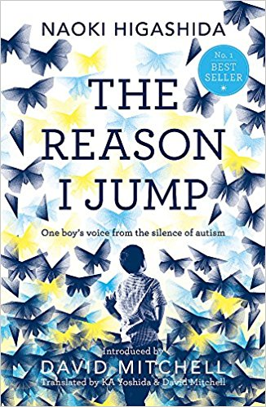 | The Reason I Jump: one boy’s voice from the silence of autism, Naoki Higashida and David Mitchell  Written by Naoki Higashida when he was only thirteen, this remarkable book provides a rare insight into the often baffling behaviour of autistic children. Using a question and answer format, Naoki explains things like why he talks loudly or repeats the same questions, what causes him to have panic attacks, and why he likes to jump. He also shows the way he thinks and feels about his world - other people, nature, time and beauty, and himself. Abundantly proving that people with autism do possess imagination, humour and empathy, he also makes clear how badly they need our compassion, patience and understanding.  David Mitchell and his wife have translated Naoki's book so that it might help others dealing with autism and generally illuminate a little-understood condition. It gives us an exceptional chance to enter the mind of another and see the world from a strange and fascinating perspective.  **WE HOLD 2 COPIES OF THIS BOOK**
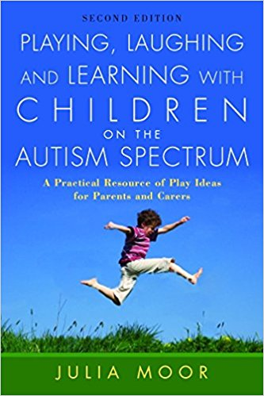 | Playing, Laughing and Learning With Children on the Autism Spectrum: A Practical Resource of Play Ideas for Parents and Carers, Julia Moor  Parents of young children newly diagnosed as on the autism spectrum are often at a loss for ideas about how best to help their child. Playing, Laughing and Learning with Children on the Autism Spectrum is not just a collection of play ideas; it shows how to break down activities into manageable stages, and looks at ways to gain a child's attention and motivation and to build on small achievements.  Each chapter covers a collection of ideas around a theme, including music, art, physical activities, playing outdoors, puzzles, turn-taking and using existing toys to create play sequences. There are also chapters on introducing reading and making the most of television. This updated second edition contains an extensive chapter on how to use the computer, the internet and the digital camera to find and make resources and activities, and suggests many suitable websites to help parents through the internet maze. The ideas are useful both for toddlers and primary age children who are still struggling with play.
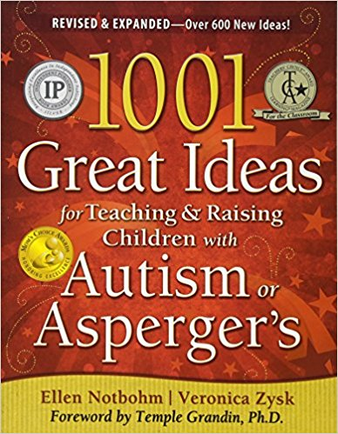 | 1001 Great Ideas for Teaching and Raising Children With Autism or Asperger's, Ellen Notbohm & Veronica Zysk  Ellen Notbohm and Veronica Zysk are authors who know how to take their own advice. Winner of Learning Magazine's Teachers’ Choice Award, the first edition of 1001 Great Ideas has been a treasured resource in the autism community since 2004. Now, in this expanded edition, Ellen Notbohm (best-selling author of the revolutionary book Ten Things Every Child with Autism Wishes You Knew) and Veronica Zysk (award-winning author and editor of Autism Asperger's Digest magazine) present parents and educators with over 1800 ideas—try-it-now tips, eye-opening advice, and grassroots strategies.  More than 600 fresh ideas join tried and true tactics from the original edition, while many ideas pick up where the first edition left off, offering modifications for older kids, honing in on Asperger’s challenges, and enhancing already-effective ways to help your child or student achieve success at home, in school, and in the community. It helps you quickly find solutions, explanations, and strategies that speak to the variety of developmental levels, learning styles, and abilities inherent in children with autism or Asperger’s.
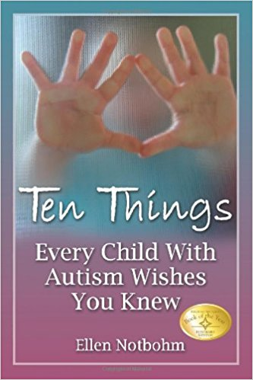 | Ten Things Every Child With Autism Wishes You Knew, Ellen Notbohm  Framed with both humour and compassion, this book defines the top ten characteristics that illuminate the minds and hearts of children with autism. Ellen’s personal experiences as a parent, an autism columnist, and a contributor to numerous parenting magazines coalesce to create a guide for all who come in contact with a child on the autism spectrum. Every parent, teacher, social worker, therapist, and physician should have this succinct and informative book in their back pocket.  Table of Contents  Chapter 1: I am first and foremost a child  Chapter 2: My sensory perceptions are disordered  Chapter 3: Distinguish between won’t and can’t  Chapter 4: I am a concrete thinker. I interpret language literally  Chapter 5: Be patient with my limited vocabulary  Chapter 6: Because language is so difficult for me, I am very visually oriented  Chapter 7: Focus and build on what I can do rather than what I can’t do  Chapter 8: Help me with social interactions  Chapter 9: Identify what triggers my meltdowns  Chapter 10: Love me unconditionally
Other booklets and information guides | Information About Autism Spectrum Disorders – published by Early Support.  Visiting the West Sussex Countryside: A guide for Parents and Teachers of Children with Autism.  Sensory Issues In Autism: How You Can Help – published by Centre for Research in Autism and Education (CRAE) (We hold 2 copies).

Behaviour

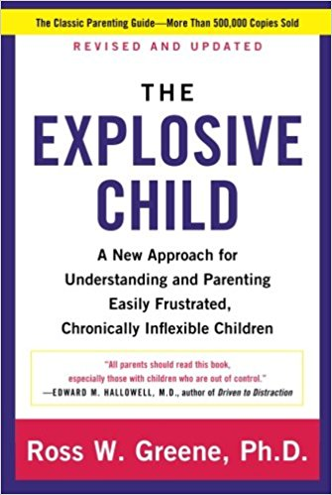 | The Explosive Child: A New Approach for Understanding and Parenting Easily Frustrated, Chronically Inflexible Children, Ross W Greene  A ground-breaking approach to understanding and parenting children who frequently exhibit severe fits of temper and other intractable behaviours, from a distinguished clinician and pioneer in this field.  What’s an explosive child? A child who responds to routine problems with extreme frustration – crying, screaming, swearing, kicking, hitting, biting, spitting, destroying property, and worse. A child whose frequent, severe outbursts leave his or her parents feeling frustrated, scared, worried, and desperate for help. Most of these parents have tried everything –reasoning, explaining, punishing, sticker charts, therapy, medication – but to no avail. They can’t figure out why their child acts the way he or she does; they wonder why the strategies that work for other kids don’t work for theirs; and they don’t know what to do instead.  Dr Ross Greene, a distinguished clinician and pioneer in the treatment of kids with social, emotional, and behavioural challenges, has worked with thousands of explosive children, and he has good news: these kids aren’t attention-seeking, manipulative, or unmotivated, and their parents aren’t passive, permissive pushovers. Rather, explosive kids are lacking some crucial skills in the domains of flexibility/adaptability, frustration tolerance, and problem solving, and they require a different approach to parenting.  Throughout this compassionate, insightful, and practical book, Dr Greene provides a new conceptual framework for understanding their difficulties, based on research in the neurosciences. He explains why traditional parenting and treatment often don’t work with these children, and he describes what to do instead. Instead of relying on rewarding and punishing, Dr Greene’s Collaborative Problem Solving model promotes working with explosive children to solve the problems that precipitate explosive episodes, and teaching these kids the skills they lack.
Other booklets and information guides | Information About Behaviour – published by Early Support.

Carer’s Support

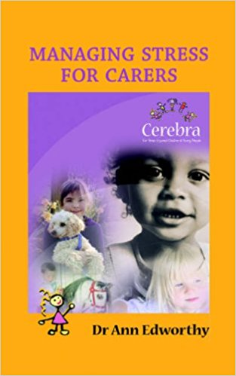 | Managing Stress for Carers, Dr Ann Edworthy  A guide to the all of the issues facing parents with a child suffering from a neurological condition. The book analyses the problems faced and provides a wide range of information about how to get help.

Cerebral Palsy

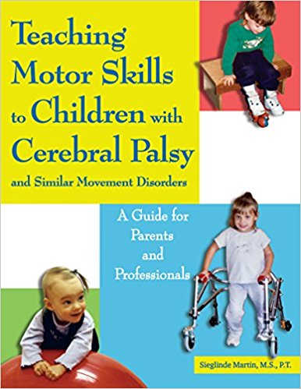 | Teaching Motor Skills to Children With Cerebral Palsy and Similar Movement Disorders, Sieglinde Martin  Written by an experienced physical therapist, this practical guide gives parents the keys they need to help their child with cerebral palsy or another developmental delay master gross motor skills beginning in infancy. Organised in the sequence children acquire gross motor skills, this guide explains how motor development unfolds, and how cerebral palsy can affect this development. There are dozens of illustrated exercises that can help children gradually strengthen back, neck and tummy muscles and then master motor skills, such as head control, sitting, crawling, standing, and walking. While parents can and should practice these exercises at home, the author stresses how success is dependent on parents and therapist working together. Real-life vignettes provide examples of how parents, children, and physical therapists interact, what difficulties can arise and how to try and work through them.
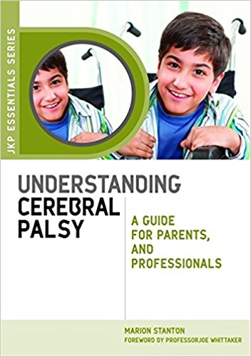 | Understanding Cerebral Palsy: A Guide for Parents and Professionals, Marion Stanton  An invaluable starting point for anyone encountering cerebral palsy for the first time, this book provides essential background information on causes, types and symptoms, as well as vital advice about the treatments, therapies and sources of support available. Practical tips on everyday considerations such as communication, diet and education will help parents achieve the best quality of life for their child. A final chapter explores options after compulsory education and how best to support a young person making the transition to independent adulthood. Using personal experience and case studies as sources of inspiration, as well as a comprehensive list of resources to signpost readers to further information, this positive handbook will help parents and professionals more fully understand cerebral palsy and the different options available to people with the condition.
Other booklets and information guides | Cerebral Palsy book – published by Scope.  Information About Cerebral Palsy – published by Early Support.

Communication

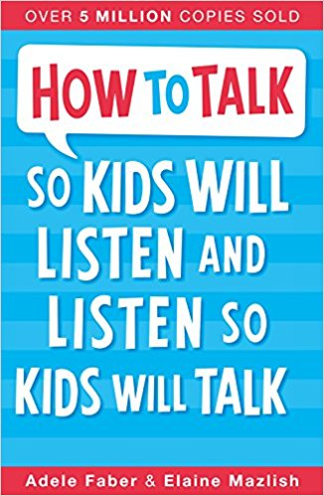 | How To Talk So Kids Will Listen & Listen So Kids Will Talk, Adele Faber & Elaine Mazlish  Parenting experts Adele Faber and Elaine Mazlish provide effective step by step techniques to help you improve and enrich your relationships with your children.  Learn how to:  · Break a pattern of arguments.  · Cope with your child's negative feelings.  · Engage your child's co-operation.  · Set clear limits and still maintain goodwill.  · Express your anger without being hurtful.  · Resolve family conflicts peacefully.
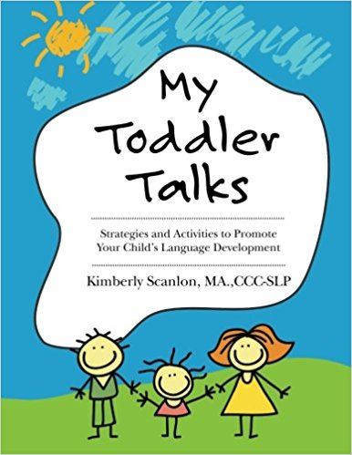 | My Toddler Talks, Kimberley Scanlon  Are you concerned that your child is not talking as much as his peers? Is he growing increasingly frustrated because he can't tell you his wants and needs? Bring out the toys and get ready to shake up your perspective -we're going to ease your frustration and learn some tried and true techniques to get your toddler talking! My Toddler Talks, by Kimberly Scanlon, is a must-have for anyone interested in developing language in young children. Learn how to model and elicit language in a fun, straightforward and practical manner from an experienced & licensed speech language pathologist. Textbook theory and evidenced-based speech therapy techniques are applied in an enjoyable and user-friendly way.  Whether you're a parent or a professional, Kimberly shows you how to engage your toddler with play routines that stimulate speech while having fun.  The guide includes detailed steps, numerous examples, and play routine activities to facilitate learning and language development.  -Effective language stimulation tips, techniques and strategies used by professional speech therapists.  -Advice on how to maximize your child's potential without causing pressure or frustration.  -25 fun play routines designed to improve your child's speech and language skills.  -Straightforward instructions with many examples to foster understanding and empowerment.  -Step by step directions on how to elicit communication from your child.  -Charts to monitor progress with your child.  -A system to track your child's word growth.  -Ways to incorporate speech development activities into your daily routines.  -Recommended goals to drive results.  -Ideas for troubleshooting development setbacks.
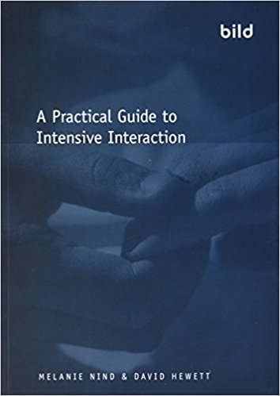 | A Practical Guide to Intensive Interaction, Melanie Nind & Dave Hewitt  Communication Intensive Interaction provides simple yet highly effective techniques for communicating with people with severe learning disabilities. The authors, pioneers of Intensive Interaction and leading experts in the field, have produced a highly practical, accessible guide which draws on the latest thinking and practice. The guide is suitable for anyone new to Intensive Interaction, and those with some experience, including:  - Direct care staff, including classroom assistants and class teachers.  - Families and other carers of people with profound and multiple learning disabilities.  - Managers of services, including team leaders.  It includes numerous case studies and examples, guidelines for troubleshooting, checklists and suggestions for further reading.
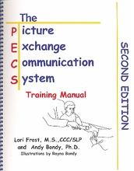 | The Picture Exchange Communication System Training Manual, Lori Frost and Andrew Bondy  The 2nd edition of this very popular training manual provides comprehensive instruction in implementing the Picture Exchange Communication System. Developed by Lori Frost and Andy Bondy, the goal of PECS is to provide individuals with an effective and functional method of communication. The Training Manual begins with a description of the Pyramid Approach to Education, which is the foundation for creating all PECS lessons. A detailed chapter on functional communication follows. Each of the 6 training phases is described according to rationale, training steps, frequently asked questions, helpful hints and sample data sheets. Extensive indices provide reproducible evaluation forms, data sheets, reinforcer worksheets, and communication programming worksheets.

Dyslexia
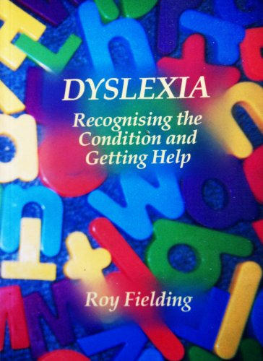 | Dyslexia: Recognising the Condition and Getting Help, Roy Fielding  Need help and advice then this book’s for you. Compiled from questions thousands of you asked the Helpline (free assessment; misdiagnosed as ADHD; what can I do; am I being fobbed off), seeking meaningful and truthful answers they could not easily find elsewhere.  Such topics tended to be about the misdiagnosis of ADHD and why, getting a free dyslexia assessment from a fully qualified Educational Psychologist; what dyslexia actually was; poor behaviour; school phobia and other common problems; poor self esteem; knowing your rights and how to get help. However, the book deals with literally hundreds of related questions.  Parents often describe the book as a godsend or as the one book that seems to be written for them, they commonly say there is no other book like it on the market.

Epilepsy

Other booklets and information guides | Epilepsy Action information pack  Epilepsy in Infants and Young Children – Published by Young Epilepsy (We hold 4 copies)  All about Epilepsy: Children’s leaflet – Published by Young Epilepsy (We hold 4 copies)

Home Education

No-Sweat Home Schooling – The Low Stress Way to Teach Your Kids, Kelly Wallace
Kelly Wallace was a homeschooling single-mom to three daughters for over a decade. During that time she learned a lot along the way, made lots of mistakes, and eventually did things right. She's written many articles on the subject of schooling from home for top blogs and website. In this book she shares these articles (revised, expanded and updated), new subjects she's written about, and her journey as a homeschooling parent. She covers subjects such as learning across the curriculum, frugal field trips, record keeping, fun math activities, teaching multiple ages, stress busters and more. She also includes dozens of quality online resources.
From The Author "The decision to homeschool your kids is one you’ll never regret, though the path can often be confusing and frustrating. I fully believe that homeschooling should be as much fun for you as it is for your children. After all, you’ll be spending many hours each week together learning new things. Why make it bland and boring? Instead, with a bit of ingenuity you can turn even the smallest everyday task into a learning opportunity that sticks with your children for life. This is what No Sweat Home Schooling is all about. I look forward to sharing my experiences and ideas with you!"

Internet Safety

Other booklets and information guides | Learning Disabilities, Autism and Internet Safety: A Guide for Parents – published by Cerebra

Learning Difficulties

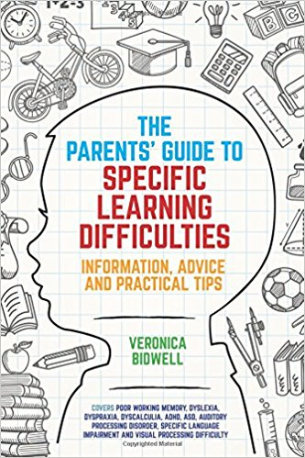 | The Parent's Guide to Specific Learning Difficulties, Veronica Bidwell  Packed full of advice and practical strategies for parents and educators, this book is a one-stop-shop for supporting children with Specific Learning Difficulties (SpLDs).  Part one introduces a spectrum of SpLDs, ranging from poor working memory, dyslexia, dyspraxia, dyscalculia, through to ADHD, Autism Spectrum Disorder (ASD), Auditory Processing Disorder (APD), Specific Language Impairment and Visual Processing Difficulty. It explains clearly what each difficulty is, how it can affect a child's learning and how to help a child to succeed despite their difficulties. Part two includes a host of tips, tools and strategies to support your child's efforts in areas such as reading, writing, spelling and handwriting, as well as advice on motivation, confidence and managing life's setbacks.  Written by an experienced Educational Psychologist, this is the perfect guide for parents and carers who are looking for ways to support their child's learning, as well as for educators and teachers looking for advice on how to differentiate lessons and motivate pupils with SpLDs.

Legal Aspects

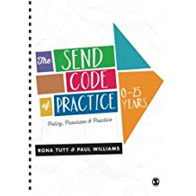 | The SEND Code of Practice, Rona Tutt and Paul Williams  How have you found the changes brought about by the new SEND Code of Practice: 0-25 years (2014)?  This book is the ultimate guide to making sure that you are not only meeting the requirements, but are improving outcomes for children and young people as well.  Written for all professionals working in the field, it covers:  - The broader Children and Families Act (2014)  - The role of the local authority  - Guidance on all the key changes that school leaders, SENCO's, and staff are concerned about  - Case studies of settings across the 0-25 age range, including maintained schools, academies, free schools, and specialist and alternative provision.  Whether you work in education, health, or social care, or are training to do so, this book will genuinely improve your provision and practice for children and young people with SEND.
Other booklets and information guides | School Transport: A Guide for Parents in England – published by Cerebra  Social Care in England: A Guide for Parents – published by Cerebra  Decision-making, Confidentiality and Sharing Information: A Guide for Parents – published by Cerebra

Pathological Demand Avoidance

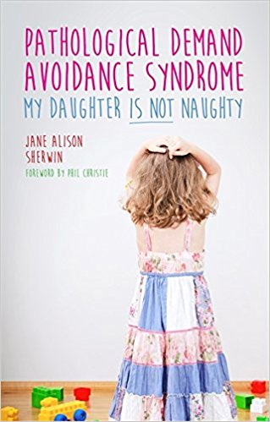 | Pathological Demand Avoidance Syndrome – My Daughter IS NOT Naughty, Jane Alison Sherwin  Jane Alison Sherwin's honest and uplifting account provides insight into the challenges of bringing up a child with Pathological Demand Avoidance (PDA).  After years of misdiagnosis, Jane's daughter, Mollie, was diagnosed with PDA at the age of seven, and we follow her experiences pre and post diagnosis to age 10 as she attends school, interacts with the outside world and approaches adolescence. Throughout, Jane provides commentary on her daughter's behaviour and the impact it has on her family, explaining the 'why' of PDA traits, including the need for control, meltdowns, obsessive behaviour and sensory issues. She reveals the strategies that have worked for Mollie and provides essential advice and information on obtaining a diagnosis and raising awareness of PDA. The book also includes an interview with Mollie.  Full of advice and support, and with a focus on understanding the child and how he or she sees the world, this book will be of immeasurable value to the parents and families of children with PDA as well as the professionals working with them, particularly teachers and teaching assistants, SEN co-ordinators, psychologists, outreach workers and social workers.

Premature Babies

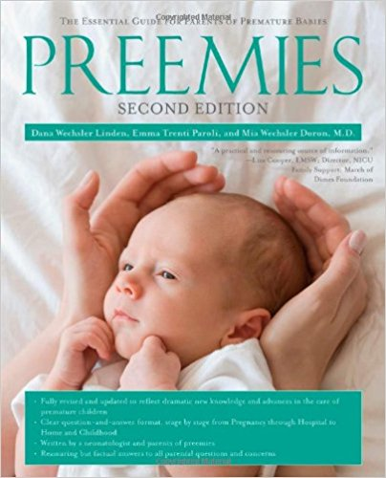 | Preemies: The Essential Guide for Parents of Premature Babies, Dana Wechsler Linden and Emma Trenti Paroli  Preemies, Second Edition is the only parents' reference resource of its kind, delivering up-to-the-minute information on medical care in a warm, caring, and engaging voice. Authors Dana Wechsler Linden and Emma Trenti Paroli are parents who have "been there". Together with neonatologist Mia Wechsler Doron, they answer the dozens of questions that parents will have at every stage – from high-risk pregnancy through preemie hospitalisation, to homecoming and the preschool years – imparting a vast, detailed store of knowledge in clear language that all readers can understand.  Preemies, Second Edition covers topics related to premature birth, including:  What are your risk factors for having a premature baby?  Can you do something to delay early labour?  What do doctors know about you baby's outlook during her first minutes and days of life?  How will your preemie's progress be monitored?  How do you cope with a long hospitalsation?  Are there special preparations for you baby's homecoming?  What kind of stimulation during the first year gives your baby the best chance?  Will your preemie grow up healthy?

Sensory Processing Disorder

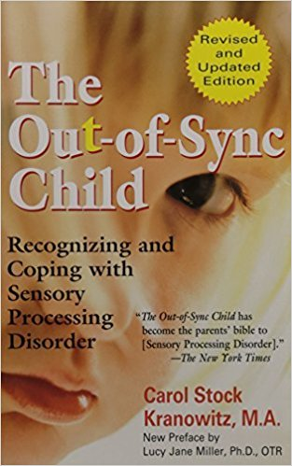 | The Out-of-Sync Child: Recognizing and Coping with Sensory Processing Disorder, Carol Stock Kranowitz  The revised edition of the ground-breaking 1998 book that introduced Sensory Processing Disorder (SPD) to parents, teachers, and other non-specialists. SPD is a common and frequently misdiagnosed problem in which the central nervous system misinterprets messages from the senses. This new edition features additional information on visual and hearing deficits, motor skill difficulties, ADHD, autism, Asperger syndrome, and other related disorders.
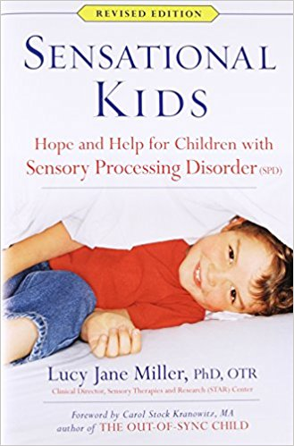 | Sensational Kids: Hope and Help for Children with Sensory Processing Disorder (SPD), Lucy Jane Miller  Sensory Processing Disorder is an increasingly common diagnosis, with a wide range of symptoms that can be difficult for parents and paediatricians to identify. In Sensational Kids, internationally renowned expert Dr Miller shares her more than forty years of experience and research findings on SPD. Now in its fourteenth printing, with more than 50,000 copies sold in all formats, it is an authoritative and practical guide to understanding and treating this little-understood condition.  Newly updated, this revised edition will include the latest research on SPD's relationship to autism, as well as new treatment options and coping strategies for parents, teachers, and others who care for kids with SPD.  Other topics include:  - The signs and symptoms of SPD  - Its four major subtypes  - How the disorder is diagnosed and treated sensory strategies to help SPD kids develop, learn and succeed, in school and in life.
Other booklets and information guides | The Sensory Sensitive Home – published by WSCC Social Communication Team.  Pain: A Guide for Parents – published by Cerebra

Signing

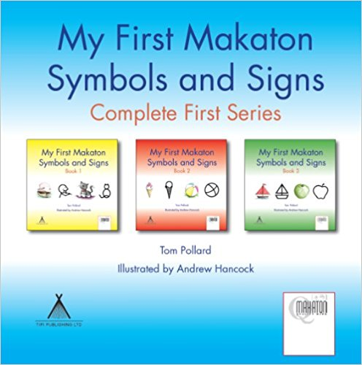 | My First Makaton Symbols and Signs Complete First Series, Tom Pollard & Andrew Hancock  My First Makaton Symbols and Signs Books 1, 2 and 3 form a unique series of beautifully illustrated children's books designed to be read for pleasure. The illustrations and text are accompanied by Makaton Symbols and Signs which encourage the development of essential communication and literacy skills. Parents and children, at any level, can understand and enjoy reading these books together. They include instructional text and cover a range of Makaton Signs carefully chosen to help babies and young children express their needs and begin to interact with people around them.  The following signs are included.  Book 1: mum, dad, baby, teddy, drink, milk, eat, biscuit, cat, dog, bird, tree, car, house, potty, nappy, bath, cuddle, book, read, bed, sleep, hello, goodbye, good, bad, what, where, here, there, yes, no, help and look.  Book 2: boy, girl, flower, butterfly, bus, aeroplane, fish, rabbit, ice cream, cake, ball, doll, swim, run, jump, kick, ride a bicycle, friend, toilet, wash, brush hair, brush teeth, more, please, finished, thank you, hot, cold, little, big, my, your, sorry and want.  Book 3: apple, banana, train, boat, cow, pig, horse, sheep, farm, playground, happy, sad, bricks, build, toys, play, paint, write, coat, shoes, get dressed, get undressed, which, who, like, beautiful, listen, noise, sing, speak, go, ill, I, love, you.  The Makaton Symbols presented with written words are also a great way to build children's confidence whilst learning to read. Text is a very abstract concept for young children to grasp but by using iconic symbols together with words the process becomes much more intuitive. My First Makaton Symbols and Signs Complete First Series also carries the Makaton Quality Mark, an accreditation reserved for materials that have been approved by The Makaton Charity and which meet criteria set to a high standard of translation.
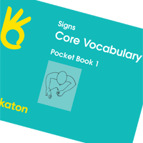 | Signs: Core Vocabulary Pocket Book 1 – published by the Makaton Charity  Covers Stages 1, 2, 3, 4 and additional
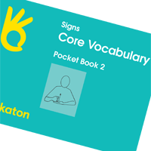 | Signs: Core Vocabulary Pocket Book 2 – published by The Makaton Charity  Covers Stages 5, 6, 7 and 8
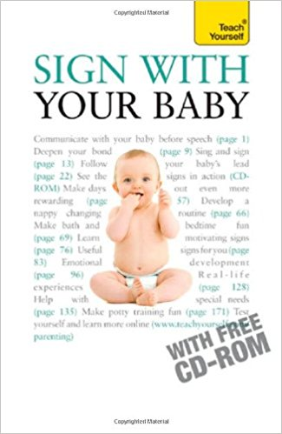 | Sign With Your Baby, Jane Jarvis  Sign with Your Baby is the first comprehensive guide to signing with your baby to be produced by British authors. Unlike the many dictionaries on the market, it provides both practical and background information on how signing to and with your young child can enhance your communication, emotional bond and their language/behavioural development in many different ways.  Authored in conjunction with the UK's most respected courses, 'Sing and Sign', the book offers firstly a full overview of the history and benefits of signing before outlining the essential signs and moving on to more detailed communication with your baby. From bilingual to special needs children, and covering development right up to the learning of the alphabet and phonics for older children.

Sleep

Other booklets and information guides | Information About Sleep – published by Early Support.  Sleep: A Guide for Parents – published by Cerebra

Special Needs – Identifying

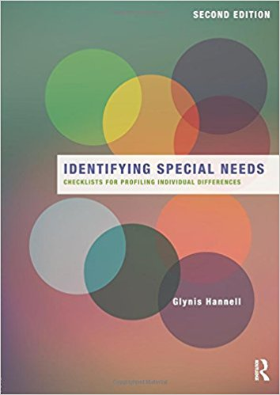 | Identifying Special Needs, Checklists for Profiling Individual Differences, Glynis Hannell  Drawing from her experience as an educational psychologist, and special education teacher, Glynis Hannell offers guidelines to help teachers quickly recognise and categorise the specific characteristics of developmental disorders, autism spectrum disorders, emotional-behavioural disorders, specific learning disorders, sensory impairments and other forms of special need.  The practical checklists and resources in this fully revised new edition help both classroom and specialist teachers to:  - Screen any student for possible special needs  - Understand the causes and characteristics of various types of special needs  - Request and prepare for an intervention or IEP team meeting  - Link classroom observations to diagnostic criteria used by specialists  - Create accurate and comprehensive profiles for individual students  - Record each student’s unique pattern of development within a special needs ‘label’  - Quickly record important information and avoid writing time-consuming reports  - Co-ordinate information from several teachers or professionals  - Monitor progress and track significant changes over time  - Involve parents in observing and discussing their child’s pattern of strengths and challenges  - Plan effective, inclusive intervention in the classroom setting  - Follow up with recommended further reading, websites and professional references  Recognising special needs and identifying each student’s unique profile of positive attributes and difficulties enables teachers and other educational professionals to ensure that all their students receive the support they need to succeed.

Tubefeeding

Complete Tubefeeding, Eric Aadhaar O'Gorman
Complete Tubefeeding is the definitive guide for anyone living with or preparing to receive a feeding tube, and those who care for them. The author, happy owner of a feeding tube himself, combines the best and latest medical research with insights from his and others’ real-world tube feeding experiences. This helpful handbook provides comprehensive and compassionate coverage of all aspects of tube feeding and nutrition via tube, including:
The different types of enteral feeding tubes, their placement, use and care, with loads of useful tips and tricks to make living with a feeding tube easy as can be.
Tube nutrition, with sections on commercially available formulas as well as a detailed approach to a blended diet (sometimes known as a blenderised diet) — how to use real food for tube feeding while ensuring complete nutrition and stress-free management of blending.
Commonly faced problems with tubefeeding, discussed at length and with solutions presented, ranging from possible medical complications to psychological and emotional issues and the impact on family life. The introduction of a feeding tube within the family can be a time of fear and isolation, and even for many a sense of helplessness.
Complete Tubefeeding empowers readers with a treasure trove of targeted, practical information, presented in down-to-earth language for the tubie, parent, carer and professional alike. Those just starting out on the tube feeding journey will reap the collected wisdom of hundreds who live and thrive with feeding tubes in addition to best practices gleaned from medical science. Those seeking nutrition information and considering a switch to a blended diet will find simple but thorough explanations and handy instructions for homemade blends. Health professionals will benefit from in-depth analysis, particularly on increasingly popular blended diets.
Also included are over 35 sample blend recipes (with nutritional information provided) to adapt and quickly put to use, all created with good health, ease, and enjoyment in mind. Alongside the invaluable knowledge of hundreds of tubie parents, carers, and tubies themselves, the author presents his own personal experiences and hands-on research.

